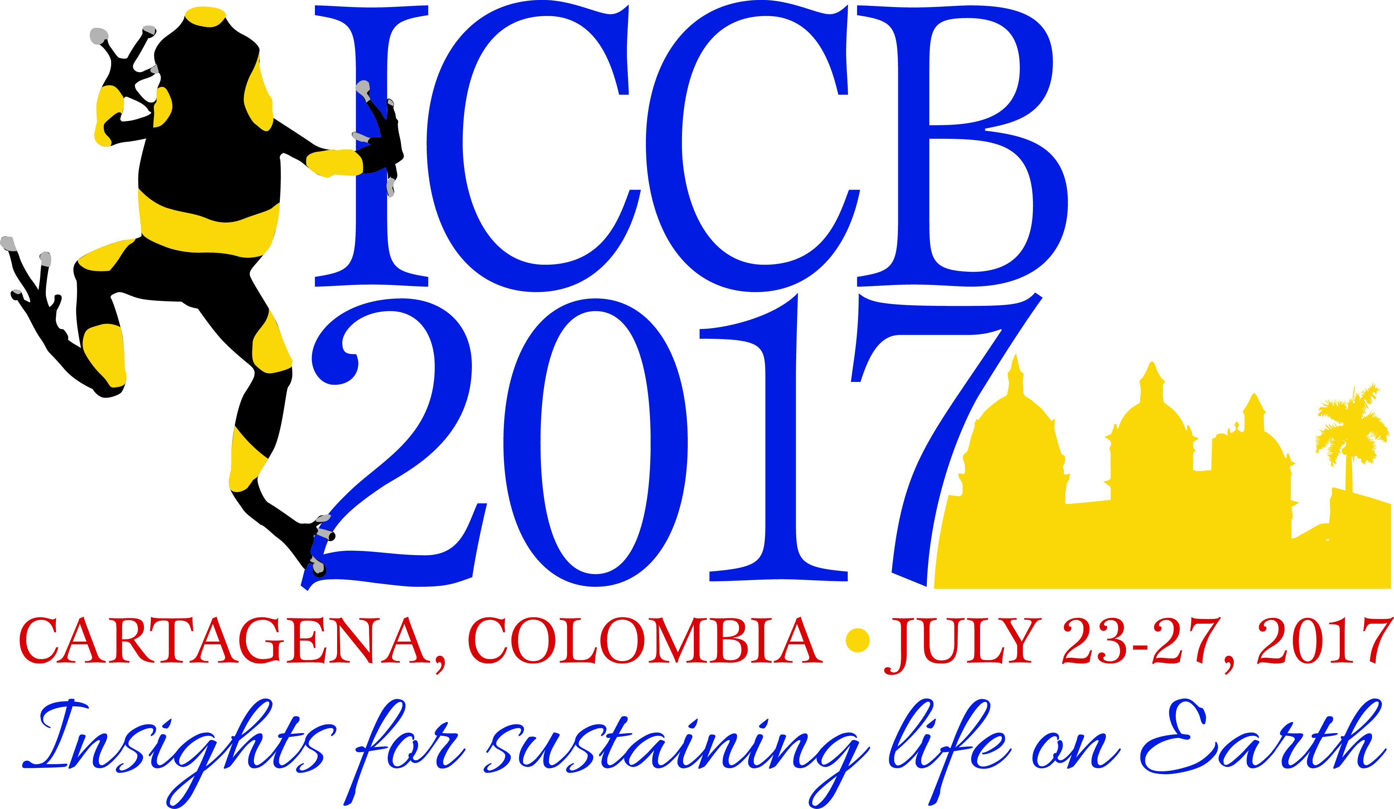
ICCB 2017
Insights for sustaining life on Earth
T-Shirt Design Contest Entry Form
Deadline: Entries due by 1 May 2017
Complete and submit this entry form along with your design to ICCB Communications Committee Chair Rachel Golden Kroner at iccbtshirt@conbio.org.
First Name:
Last Name:
Address:
City/State/Postal Code:
Country:
E-mail:
Phone:
I am 18 or older: __________________ (yes/no)

T-shirt color on which my design will look best: ____________________ (light/dark/other*)
*Please specificy color
Tell us about your design. What does it represent and why did you enter the contest.

Signature: _________________ Date: ________________

I have read and understand the contest rules: __________________ (yes/no)
If you are submitting the form via email, please type e-signature in parentheses next to your name)

